ANALYTICS BENCHMARK PVT LIMID

**Project Case Study**

**Project** : **Retailing Sales Analysis**

**Client :** **Cost cutter Supermarket Group**

**Role** **: Report Developer**

**Environment** **: Power BI, SQL Server, Excel, Windows 10**

**Project Summary**

Cost cutter Supermarkets Group is one of largest chain of supermarkets in the United Kingdom, having 2600 stores throughout the UK, Ireland and Poland. The products are sent to different locations, where each location is divided into different zones. It has a database which maintains the information like sales, profits, margin and contacts of customers. Using this existing database, we analyze their business moment like different product sales trends, sales profits, regional sales, top N products sales. The resulting model gives us an idea about growth in profit, prediction about increase in sales which helps the management in decision making.

**Story Telling**

**Explain about You Current Working Project**

In the Current Working Project, I am Working on the Retail Domain the Client is Costcutter Supermarket Group is one of largest chain of supermarkets in the United Kingdom, having 2600 stores throughout the UK, Ireland and Poland. The products are sent to different locations, where each location is divided into different zones. It has a database which maintains the information like sales, profits, margin and contacts of customers. Using this existing database, based on the data we are having on the the database tables we created the Reports to analyse the Business Data like,

**Reports / Dashboards**

**1.Global superstore**

**2.Over All Performance**

**3.Profit Analysis Dashboard**

**4. Profit Analysis by Country**

**1.Global superstore Report**

In this Report we will analyse the complete Business data by creating the some of the Visuals like,

**KPIS**

Total Sales

Total profit

Total Quantity

Profit Ratio

Profit per order

Top customer Sales

Total Discount

Avg Discount

**Map Visual**

To show the State wise profit Ratio

**Donut**

To show the Segment wise Profit Ratio

**Pie Chart**

To show the Category wise profit Ratio

**Matrix Visual**

To show the Sub-Category wise sales and Profit Ratio

**Line and stacked Column Chart**

To show sales and profit Ratio Trend by Year

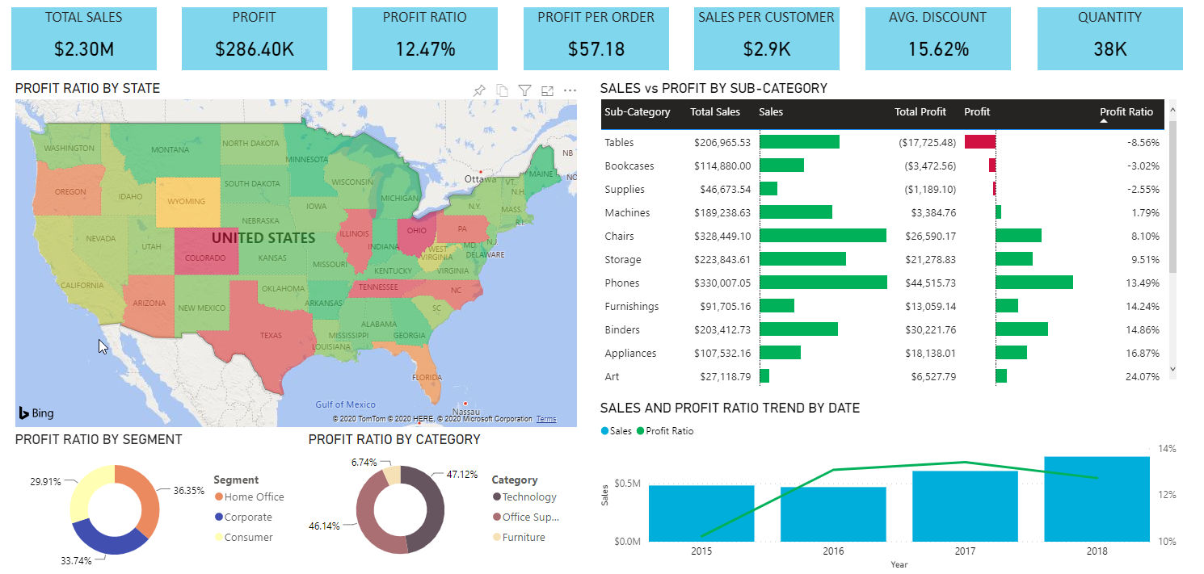

**2. Over All Performance**

In this Report we will analyse the complete Business data by creating the some of the Visuals like,

**KPIS**

Gross Sales

Sales Price

Discount

Units Sold

Revenue

Profit

**Donut Chart**

To show the Category wise discount

**Funnel Chart**

To show the Units sold by segment

**Donut Chart**

To show the Category wise profit

**Matrix Visual**

To show the Year wise and Region wise Profit, units sold, Gross sales, Discount

**Slicers**

5 Slicers

Product Slicer

Country Slicer

Brand Slicer

Segment Slicer

Date Slicer

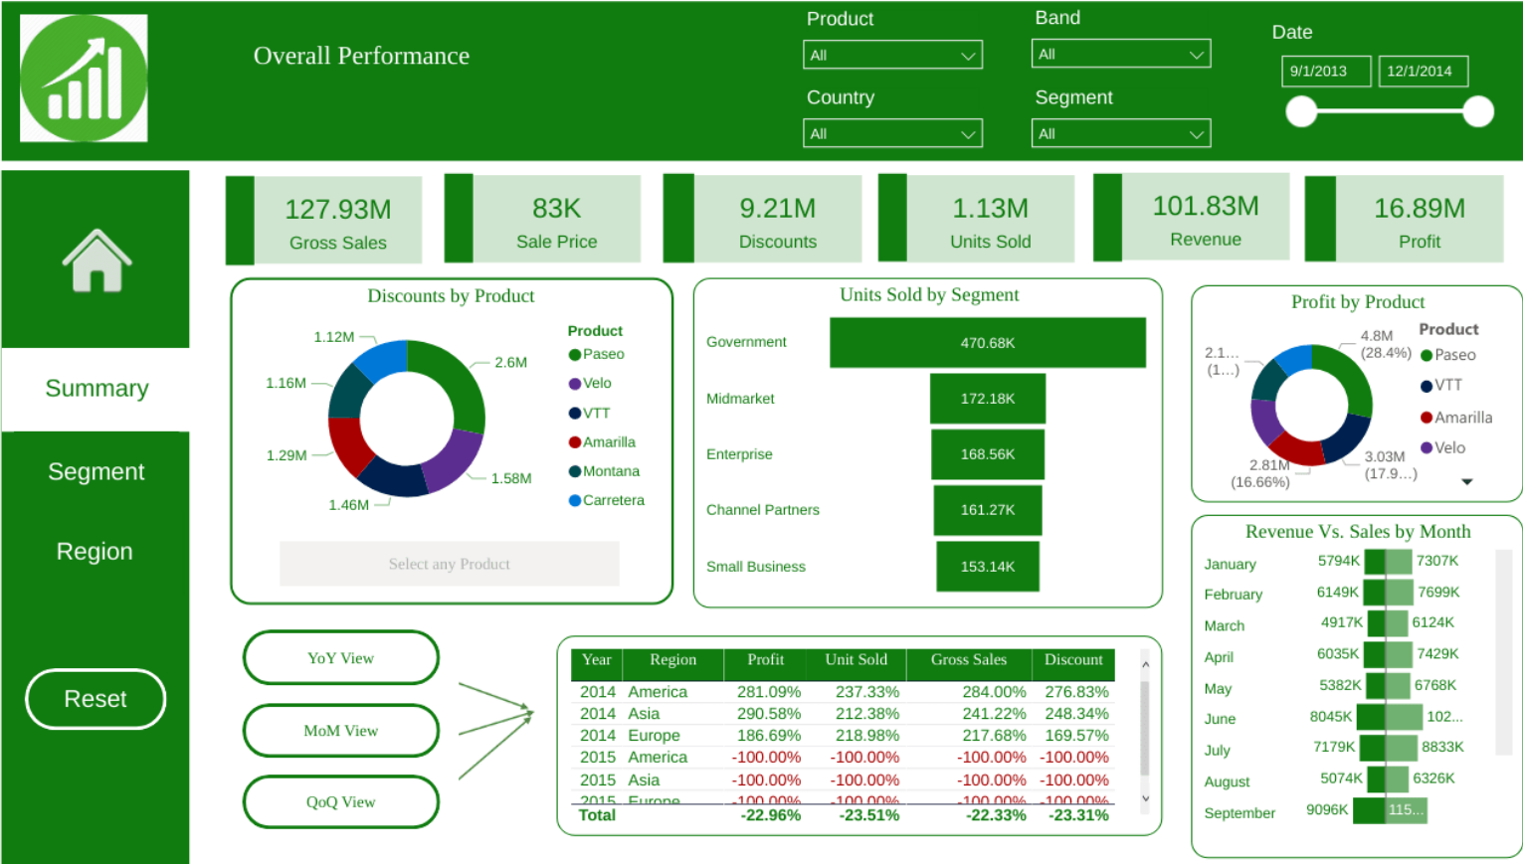

**3.Profit Analysis Dashboard**

In this Report we will analyse what is the Profit they are getting by creating the some of the Visuals like,

**KPIS**

Total Profit

Total Orders

**Slicers**

Year Slicer

Category Slicer

Region Slicer

**One Q/A Visual**

**Line Chart**

To Show the Fiscal Year wise What is the Profit they are getting

**Pie Chart**

To show each Category wise Profits and Profit Percentage

**Waterfall Chart**

To show the Profit by Year and Category

**Pie Chart**

To show the Category wise Profits

**Donut Chart**

To show the Region wise Profits

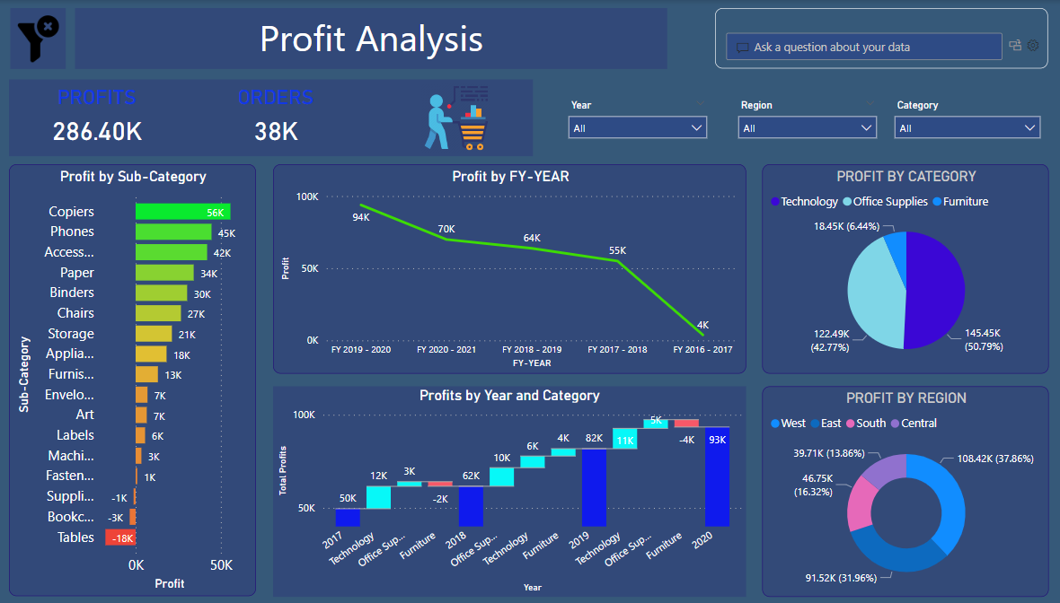

**4.Profit Analysis by Country**

**KPIS**

**Overall Profit**

Overall Profit card Visual is used to show the Profit by FY-Year,FY-Quarter,Item

When we select the values in the Slicer the Overall Profit value in the card Visual will changed based on the values we selected on the Slicers.

**Total Profit**

The Total Profit Visual will shows the Total Profit in the Business.

The value in the Total Profit won’t Change when we Click on the Values in the Slicer.

**Contribution**

This Card Visual will shows the Profit Percentage Based on the values selected in the Slicers.

**Slicers**

FY-Years

FY-Quarter

Item Type

**Card Visual**

To show the Top 1 Region which is getting more Profit Based on the values Selected in the Slicers.

**Card Visual**

To show the Top 1 Country which is getting more Profit Based on the values Selected in the Slicers.

**Card Visual**

To show the which FY-Year is getting more Profit in the complete Business Transactions and it doesn’t allows any filters by Slicer.

**Table Visual**

To show the Country wise Total Profit

**Map Visual**

Map Visual to show county wise Profits

In this we define the conditions like,

If the Profit is between 0 - 1000000 --> Red Colour

If the Profit is between 1000000 - 2500000 --> Yellow Colour

If the Profit is between 2500000 - Max --> Green Colour

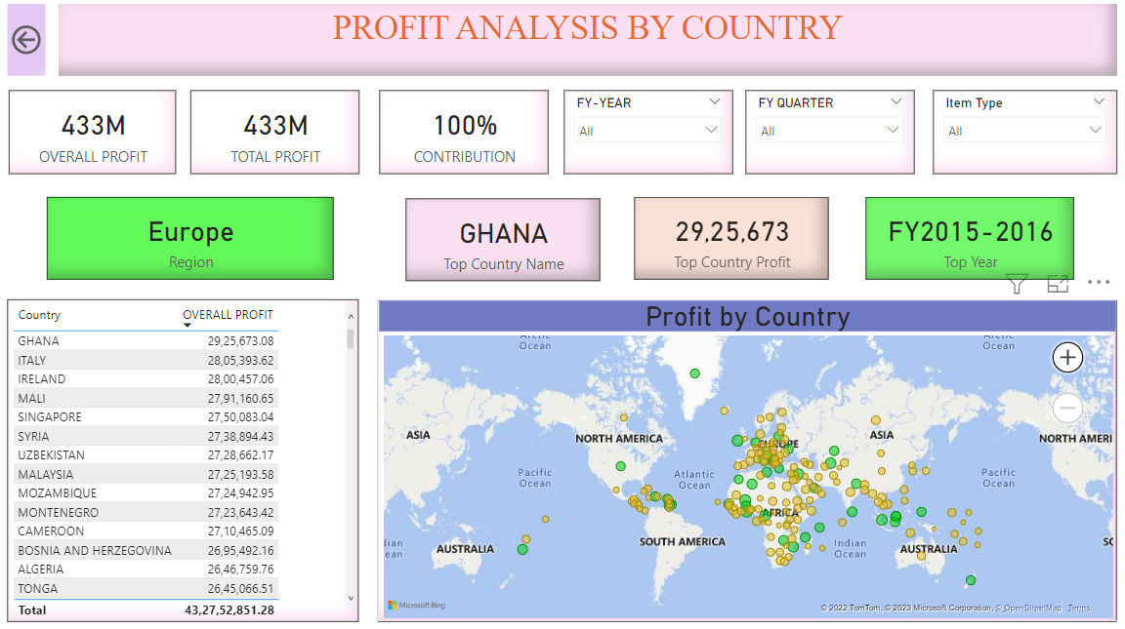

**we analyze their business moment like**

different product sales trends, sales profits, regional sales, top N products sales. The resulting model gives us an idea about growth in profit, prediction about increase in sales which helps the management in decision making.